Manual Test Plan

1. **Landing page**

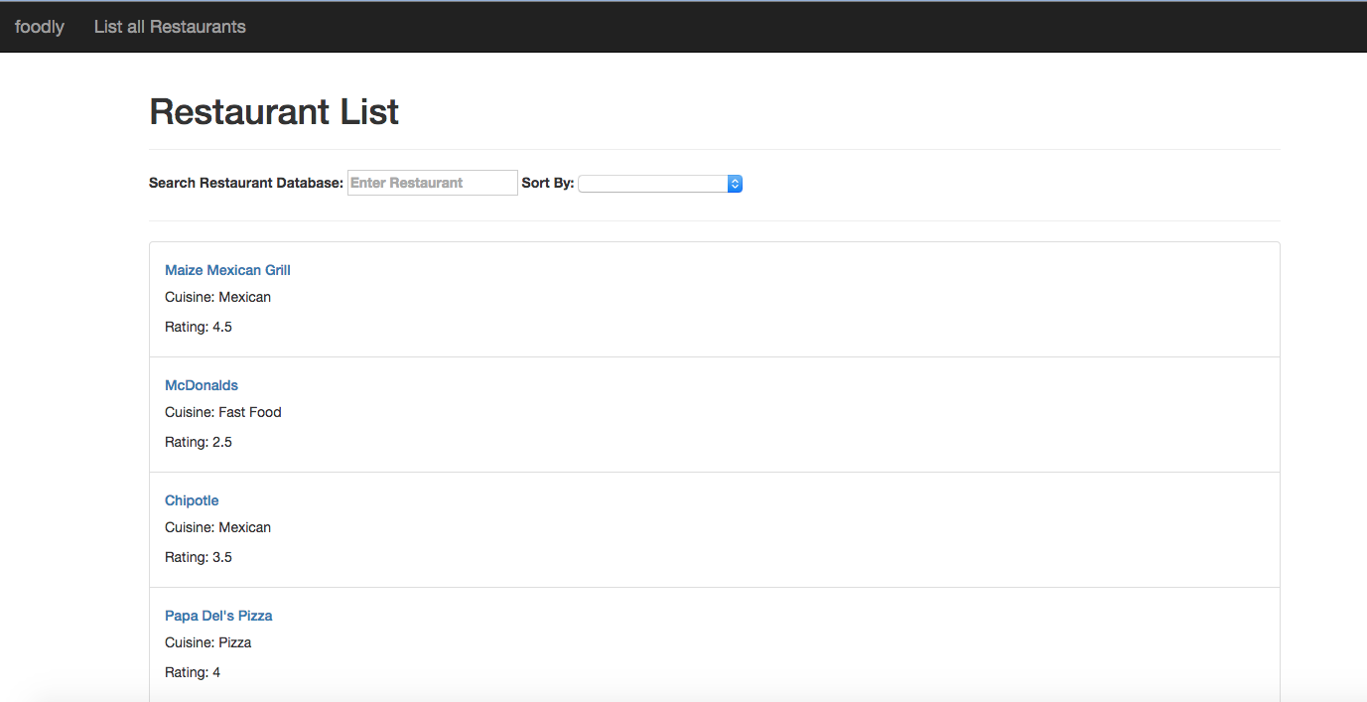

* 1. Navigate to local host in the address bar to display main landing page. The page should consist of a list of restaurants in Champaign-Urbana (limit 30).
  2. Each restaurant in the restaurant list should contain the restaurants name, cuisine type, and rating

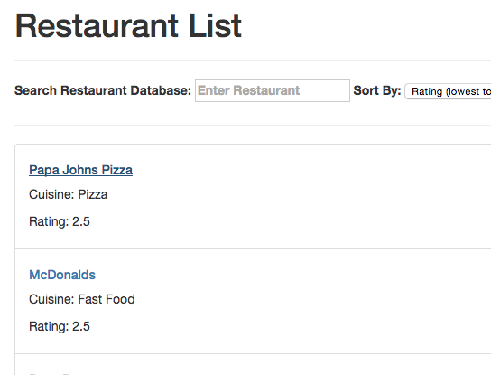

* 1. The restaurant list allow uses to search for a restaurant by name.
  2. The *sort by:* drop down provides the ability to sort the restaurants in the database by rating (lowest to highest), name (alphabetical), and cuisine type (alphabetical)

1. **Details page**
   1. Upon clicking on a specific restaurant, a details view of that restaurant should populate the window
   2. The new window should display the name, type of cuisine, rating, hours of operation, and address of the restaurant of interest

